**CMHA Kelowna Email Signature Format**

Please choose one of the options below for your email signature. Use the format provided to fill in your specific information.

* **Options #1** & **Option #2** are for staff who usually work from the Sutherland Office. If you work at one of our housing sites please see the Willowbridge example provided on the last page.
* **Option #3** is for the Foundry Kelowna team.
* **Option #4** is for the Discovery College team.

If you are unsure about which option is right for you, please connect with your Supervisor.

* **NOTE:** Below are instructions for **Outlook** signatures. **To set up your Gmail signature**, please follow the instructions in this document: <https://docs.google.com/document/d/13hM6IeyXHJMRRsebcQlqn485dAvlnUSWBorkHrnCaqE/edit?usp=sharing>

**SETUP OUTLOOK SIGNATURE**

1. Select the signature text AND image directly below it (the image will be visibly highlighted when selected). Copy the selection by either pressing **CTRL+C** on your keyboard or **right clicking > Copy** (right click above the text after everything is highlighted).
2. Open Outlook. Select **File** > **Options** > **Mail** > **Signatures**. Press the **New** button and give your signature a name. Press **OK**. Place the cursor in the Edit signature box and paste the signature by either pressing **CTRL + V** on your keyboard or **right clicking** and pressing **K**. Edit the text so that it includes your name, title and phone numbers. Click **OK.**

**OPTION #1**- Email Signature with ‘CMHA Kelowna- Operators of Foundry Kelowna’ image

**First Last**

*Title*

**CMHA Kelowna**

Canadian Mental Health Association, Kelowna & District Branch

504 Sutherland Avenue, Kelowna, BC V1Y 5X1

Tel: 123.456.7891 ext. 134 | Mobile: 234.567.8910 | [www.cmhakelowna.org](http://cmhakelowna.com/)  
  


**OPTION #2**- Email Signature with ‘CMHA Kelowna & Imagine Canada’ logos

**First Last**

*Title*

**CMHA Kelowna**

Canadian Mental Health Association, Kelowna & District Branch

504 Sutherland Avenue, Kelowna, BC V1Y 5X1

Tel: 123.456.7891 ext. 134 | Mobile: 234.567.8910 | [www.cmhakelowna.org](http://cmhakelowna.com/)



**OPTION #3**- Foundry Only: Email Signature with ‘Foundry Kelowna Operated by CMHA Kelowna’ logo

**First Last**

*Title*

**Foundry Kelowna**

100-1815 Kirschner Road, Kelowna, BC V1Y 6G3

Tel: 236.420.2803 | [www.foundry.bc.ca/kelowna](http://www.foundry.bc.ca/kelowna) | [www.cmhakelowna.org](http://cmhakelowna.com/)

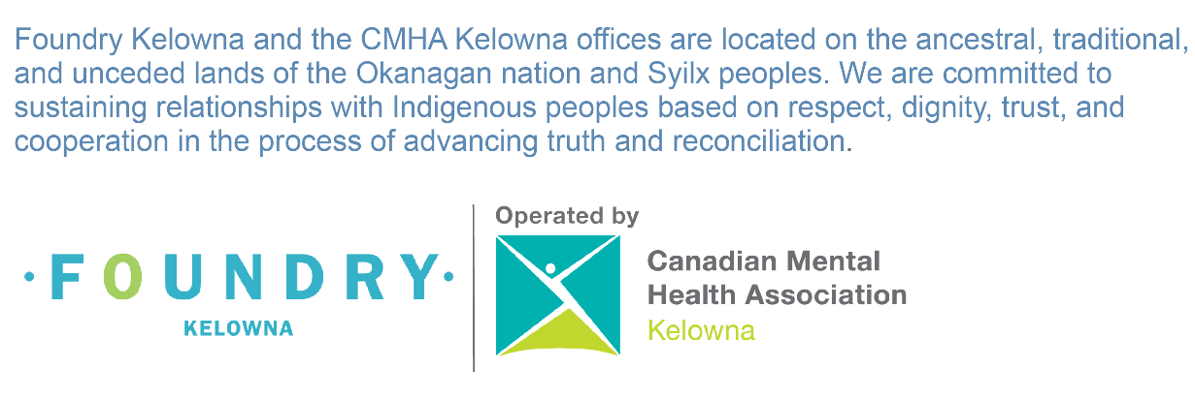

**OPTION #4**- Email Signature with ‘Discovery College- Operated by CMHA Kelowna’ image

**First Last**

*Title*

**Discovery College**

Canadian Mental Health Association, Kelowna & District Branch

504 Sutherland Avenue, Kelowna, BC V1Y 5X1

Tel: 123.456.7891 ext. 134 | Mobile: 234.567.8910 | [www.cmhakelowna.org](http://cmhakelowna.com/)



**Housing sites example:**

**Name**

*Title*

**CMHA Kelowna Willowbridge Supportive Housing**

330 Boyce Crescent, Kelowna, BC V1Y 5Z6

Tel: 778.478.0244 | Fax: 778.478.0644 | [www.cmhakelowna.org](http://cmhakelowna.com/)



**OR**

**Name**

*Title*

**CMHA Kelowna Willowbridge Supportive Housing**

330 Boyce Crescent, Kelowna, BC V1Y 5Z6

Tel: 778.478.0244 | Fax: 778.478.0644 | [www.cmhakelowna.org](http://cmhakelowna.com/)



Formatting details:

**Name:**

11pt Arial Bold

**Colours:**

RGB 0 / 177 / 176

**Title:**

11pt Arial Italic

RGB 102 / 102 / 102

**Company Name:**

11pt Arial Bold

RGB 0 / 177 / 176

**Contact Details:**

11pt Arial Regular

RGB 102 / 102 / 102

**Web Address:**

11pt Arial Regular